GameGuru Scancodes
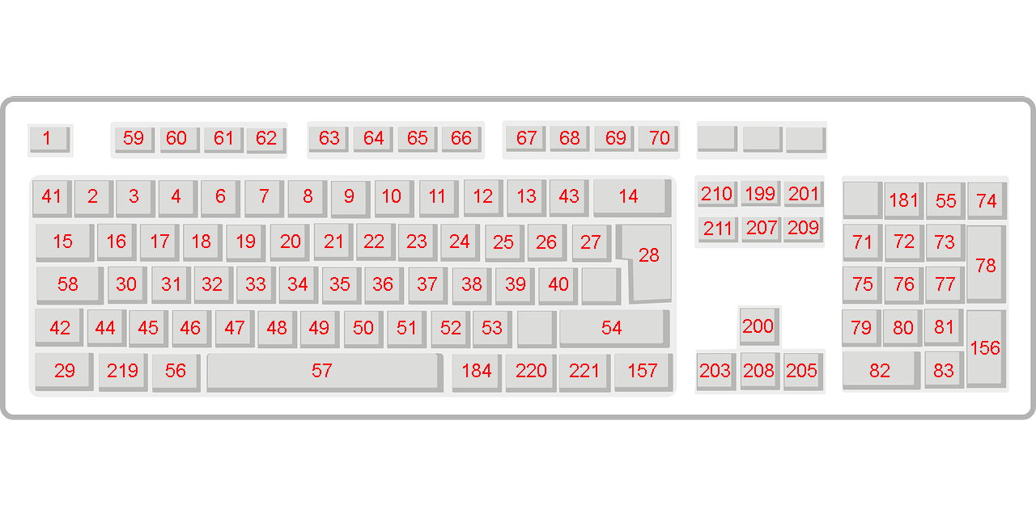
Scancodes list:
"Esc" - 1
"1" - 2
"2" - 3
"3" - 4
"4" - 5
"5" - 6
"7" - 8
"8" - 9
"9" - 10
"0" - 11
"-" - 12
"+" - 13
"Backspace" - 14
"Tab" - 15
"Q" - 16
"W" - 17
"E" - 18
"R" - 19
"T" - 20
"Y" - 21
"U" - 22
"I" - 23
"O" - 24
"P" - 25
"[" - 26
"]" - 27
"Enter" - 28
"L. Control" - 29
"A" - 30
"S" - 31
"D" - 32
"F" - 33
"G" - 34
"H" - 35
"J" - 36
"K" - 37
"L" - 38
";" - 39
""" - 40
"L. Shift" - 42
"\" - 43
"Z" - 44
"X" - 45
"C" - 46
"V" - 47
"B" - 48
"N" - 49
"M" - 50
"," - 51
"." - 52
"/" - 53
"R. Shift" - 54
"*" - 55
"L. Alt" - 56
"Space" - 57
"Caps Lock" - 58
"F1" - 59
"F2" - 60
"F3" - 61
"F4" - 62
"F5" - 63
"F6" - 64
"F7" - 65
"F8" - 66
"F9" - 67
"F10" - 68
"F11" - 69
"F12" - 70
"7" - 71
"8" - 72
"9" - 73
"-" - 74
"4" - 75
"5" - 76
"6" - 77
"+" - 78
"1" - 79
"2" - 80
"3" - 81
"0" - 82
"." - 83
"Enter" - 156
"R. Control" - 157
"R. Alt" - 184
"Home" - 199
"Up" - 200
"Page Up" - 201
"Left" - 203
"Right" - 205
"End" - 207
"Down" - 208
"Page Down" - 209
"Insert" - 210
"Delete" - 211
"L. Win" - 219
"R. Win" - 220
"Special" - 221

